**SQL ASSIGNMENT – 10**

#### 1) Write an SQL query to determine the 5th highest salary without using TOP or limit method.

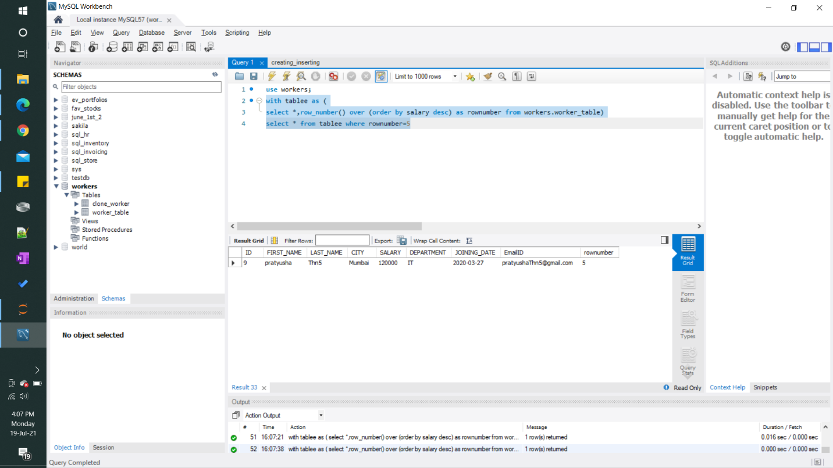

#### 2) Write an SQL query to fetch the list of employees with the same salary.

